Pompeii?
Where is Pompeii? It is in the Bay of Naples in Italy. Italy is in Europe.
Highlight number 18 on the map below. This is Italy.
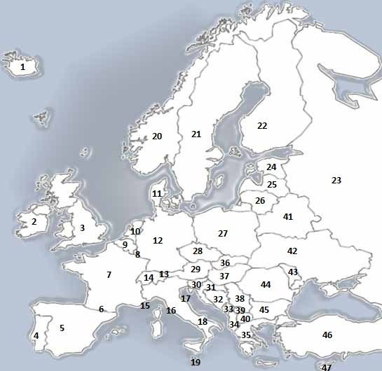
Draw a big cross on the city of Naples. The area of coastline to the East of it is the Bay of Naples.
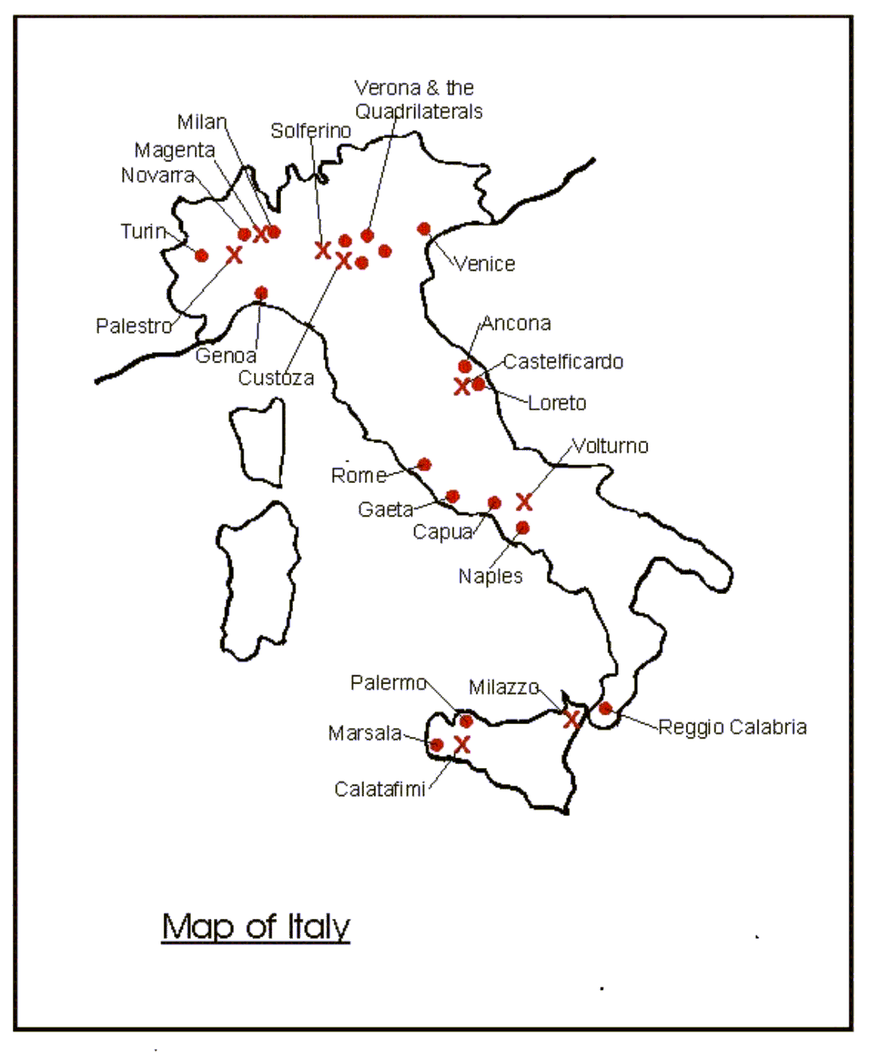
On this map highlight Vesuvius and Pompeii.
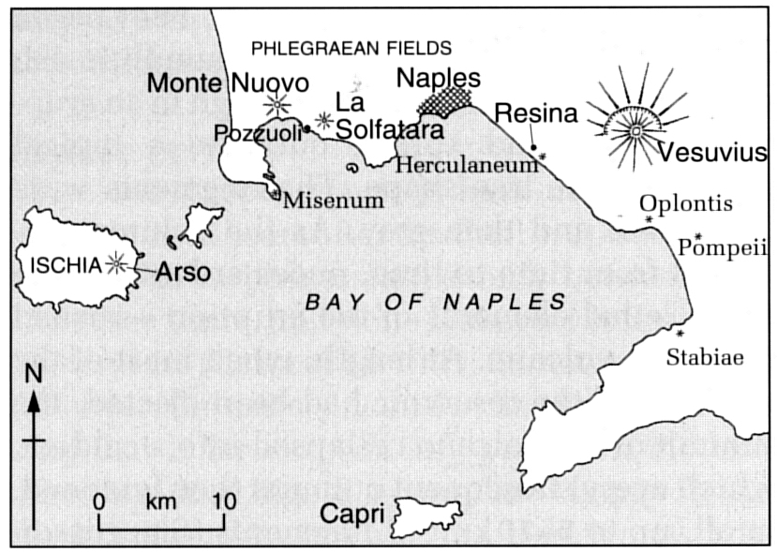
The city of Pompeii was (is) in the Bay of Naples, part of the Mediterranean Sea. It was first inhabited about 2800 years ago(700BC). The place was very good for people to settle. The nearby sea provided an abundant harvest of fish. The soil of the area was rich and dark, producing good crops, especially when coupled with the warm climate. A river, the Sarno, provided plenty of fresh water for drinking. Much of the city's wealth could be traced to the rich soil of the area, so fertile that three crops of grain could be grown in a single year. Rows of vines supplied the grapes for the area's noted wine production. On the lower slopes of Vesuvius, groves of olive trees produced tons of olives for food and oil. Lush fields outside the city supported large flocks of sheep and a thriving wool industry.
- Why would the soil have been so good?

Pompeii grew up to be a very important town. It was a wealthy city with all the features of a successful Roman population. It had public baths, a theatre and bustling market.
IN the days before Vesuvius erupted the people living nearby had noticed some changes. Streams and wells had suddenly dried up, particularly those near Mt Vesuvius. Out in the Bay of Naples, the sea had mysteriously begun to boil in some places. Here and there even the ground had begun to rumble and quiver. Many animals—dogs, cats, mice and rats—had begun abandoning the city of Pompeii.
- Why do you think the wells were drying up?

- Why was the sea boiling in places?
The Eruption
In August of A.D. 79, the earthquake activity intensified. Then, on Aug. 24 the world ended for Pompeii.
About noon that day, as thousands of Pompeians went about their daily activities of farming, fishing, buying, selling, eating and drinking, they were startled and shaken by a deafening roar.
The top of towering and vast Mt. Vesuvius vanished in a huge explosion. Dust, red-hot coria, ash and flames were blasted kilometres into the sky.
A blanket of choking, gritty ash quickly began to cover the city. Panicked Pompeians hurried to find family members and flee, seeking safety outside the city. Others, terrified by the rain of burning ash, hurried inside, bolting doors and shutters behind them.
Eventually dusk fell. By that time a metre of ash covered everything. Some people lit torches and struggled through the ash, hoping to find safety at the port or via the roads leading out of the city.
As night came, roofs began to collapse from the weight of the ash. Some, realizing they would suffocate or be buried alive by the growing ashfall, clambered out second-floor windows, gasping for breath in the ash-choked air. Others in their desperation chopped holes through the roofs and walls of their houses to escape. A few remained behind seeking shelter wherever they could.
At one residence, a dog chained in the yard climbed higher and higher as the level of ash continued to rise. Finally, as his chain ran out and he could climb no higher, the dog suffocated as the ash covered his nose and mouth.
Throughout the night the rain of ash continued to fall. Three times during the night, avalanches of rocks, hot ash and poisonous gas surged down the mountain but fell short of enveloping Pompeii. Even so, by the time the sky lightened somewhat at dawn, seven feet of ash covered much of Pompeii.
Early that morning three more superheated avalanches, accompanied by a rain of tons of very fine ash, swallowed the city. These scorching blasts, with their poisonous gases and fumes, killed everyone that remained. There it would lay, 20 feet underground—a first-century city frozen in time until its chance discovery and identification nearly 17 centuries later. It is the fact that the city was preserved under the ash that we are able to find out so much about everyday life in Pompeii.
Because so much of Pompeii was preserved under the ash are many things we can learn about life in Roman times from the ruins of Pompeii
Graffiti from Pompeii

The graffiti on the walls of the building in Pompeii was very well preserved. It shows us that the Romans who lived here had a lot of things in common with modern graffitists. Some of the graffiti was very rude. Here are translations some of the nicer ones.
Antiochus hung out here with his girlfriend Cithera.
Epaphra, you are bald!
Samius to Cornelius: go hang yourself!
“Secundus defecated here.”
Apollinaris, the doctor of the emperor Titus, defecated well here.
Postpone your tiresome quarrels if you can, or leave and take them home with you.
Marcus loves Spendusa.
Celadus the Thracian gladiator is the delight of all the girls.
The Houses
Many of the houses were well preserved under the ash.
The houses had an atrium or entrance room. A wooden door, gave access to the atrium.
The atrium was covered by a sloping roof (compluvium) open in such a way as to channel rainwater that could be collected. Around this room ran a colonnade and a series of rooms known as cubicula, which were the family's sleeping quarters.
The atrium was followed by the tablinium (meeting and reception room) and the triclinium or dining room.
The garden opened onto the back of the house and was surrounded by a colonnade. The garden grew vegetables and herbs used in the kitchen
Larger houses had embellishments and elegant decorations.
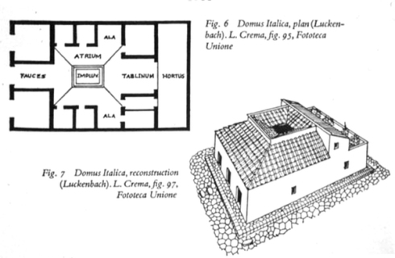
The People
One of the morbidly fascinating results of the 79 A.D. eruption of Vesuvius is the large number of holes found in the volcanic deposits around Pompeii that represented corpses of people and animals that were buried by the hot ash. The ash turned to rock before the bodies decayed so that a good mold of the deceased remained. Early in the excavation it was discovered that filling these molds with plaster produced remarkable casts of the victims of the eruption.
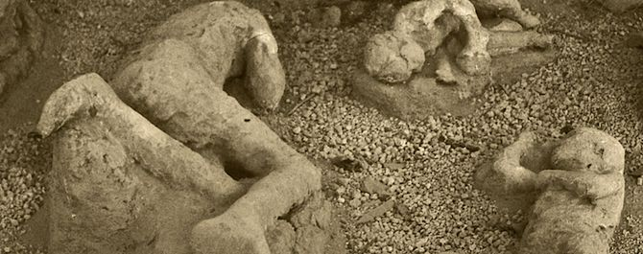

- What do you think morbidly fascinating mean?

Crossword

Across
2. The meeting and reception room in a Roman villa.
4. It was found on the walls of the buildings in Pompeii.
6. They dried up a few days before the eruption.
8. The bay where Pompeii was located.
9. It covered Pompeii.
Down
1. The continent in which Pompeii is located.
3. Plaster casts of bodies found at Pompeii.
5. The country in which Pompeii is located.
7. It started to boil in places a few days before the eruption.

